Some Additional Data Details:
Data – EQI + PLACES (joined on FIPS value)

0 tract 70962 non-null int64
1 State 70962 non-null int64
2 County 70962 non-null int64
3 RUCA_pri_cat 70962 non-null int64
4 X_pop 70962 non-null int64
5 X_sqmile 70962 non-null float64
6 X_pop_dens 70962 non-null float64
7 facilities 70962 non-null int64
8 facilities_area 70962 non-null float64
9 facilities_area_log 70962 non-null float64
10 bs_25yo 70962 non-null float64
11 time2work 70962 non-null float64
12 crime_index 70962 non-null int64
13 ln_crime_index 70962 non-null float64
14 education 70962 non-null int64
15 education_area 70962 non-null float64
16 education_area.1 70962 non-null float64
17 education_area_log 70962 non-null float64
18 food_ratio 70962 non-null float64
19 mean_drought 70962 non-null float64
20 nindex_open 70962 non-null float64
21 nata_sum 70962 non-null float64
22 nata_sum_ln 70962 non-null float64
23 ozone 70962 non-null float64
24 pm25 70962 non-null float64
25 pest 70962 non-null float64
26 ln_pest 70962 non-null float64
27 poverty 70962 non-null float64
28 ln_poverty 70962 non-null float64
29 rent_income_pct 70962 non-null float64
30 selfservice 70962 non-null float64
31 ln_selfservice 70962 non-null float64
32 unemployment 70962 non-null float64
33 ln_unemployment 70962 non-null float64
34 OverallEQI 70962 non-null float64
35 RUCA1_EQI 50827 non-null float64
36 RUCA2_EQI 6668 non-null float64
37 RUCA3_EQI 7136 non-null float64
38 RUCA4_EQI 3280 non-null float64
39 RUCA5_EQI 3051 non-null float64
40 tract_fips 70962 non-null str
41 StateAbbr 70962 non-null str
42 StateDesc 70962 non-null str
43 CountyName 70962 non-null str
44 CountyFIPS 70962 non-null int64
45 PLACES_ACCESS2 70962 non-null float64
46 PLACES_ARTHRITIS 70962 non-null float64
47 PLACES_BINGE 70962 non-null float64
48 PLACES_BPHIGH 70962 non-null float64
49 PLACES_BPMED 70962 non-null float64
50 PLACES_CANCER 70962 non-null float64
51 PLACES_CASTHMA 70962 non-null float64
52 PLACES_CERVICAL 70962 non-null float64
53 PLACES_CHD 70962 non-null float64
54 PLACES_CHECKUP 70962 non-null float64
55 PLACES_CHOLSCREEN 70962 non-null float64
56 PLACES_COLON_SCREEN 70959 non-null float64
57 PLACES_COPD 70962 non-null float64
58 PLACES_COREM 70908 non-null float64
59 PLACES_COREW 70918 non-null float64
60 PLACES_CSMOKING 70962 non-null float64
61 PLACES_DENTAL 70962 non-null float64
62 PLACES_DIABETES 70962 non-null float64
63 PLACES_HIGHCHOL 70962 non-null float64
64 PLACES_KIDNEY 70962 non-null float64
65 PLACES_LPA 70962 non-null float64
66 PLACES_MAMMOUSE 70955 non-null float64
67 PLACES_MHLTH 70962 non-null float64
68 PLACES_OBESITY 70962 non-null float64
69 PLACES_PHLTH 70962 non-null float64
70 PLACES_SLEEP 70962 non-null float64
71 PLACES_STROKE 70962 non-null float64
72 PLACES_TEETHLOST 70935 non-null float64
FIPS | A Federal Information Processing Standards code is a unique, standardized numeric identifier assigned by the U.S. Census Bureau and NIST to identify specific geographic areas, such as states and counties. These codes ensure consistent, accurate data reporting for government, research, and business, with 2-digit codes for states and 5-digit codes for counties.
https://transition.fcc.gov/oet/info/maps/census/fips/fips.txt
RUCA | USDA Rural-Urban Commuting Area codes are a classification scheme allowing for flexible, census tract delineation of rural and urban areas throughout the United States and its territories. RUCA codes were designed to address a major limitation associated with county-based classifications; they are often too large to accurately delineate boundaries between rural and urban areas. The more geographically-detailed information provided by RUCA codes can be used to improve rural research and policy—such as addressing concerns that remote, rural communities in large metropolitan counties are not eligible for some rural assistance programs.
The RUCA codes consist of two levels. The primary RUCA codes establish urban cores and the census tracts that are the most economically integrated with those cores through commuting. The secondary RUCA codes indicate whether a census tract has a strong secondary connection (through commuting) to an even larger urban core. This two-level structure provides flexibility in combining levels to meet varying definitional needs and preferences. The RUCA codes were created using census tract data and were subsequently adapted to ZIP codes.
https://www.ers.usda.gov/data-products/rural-urban-commuting-area-codes
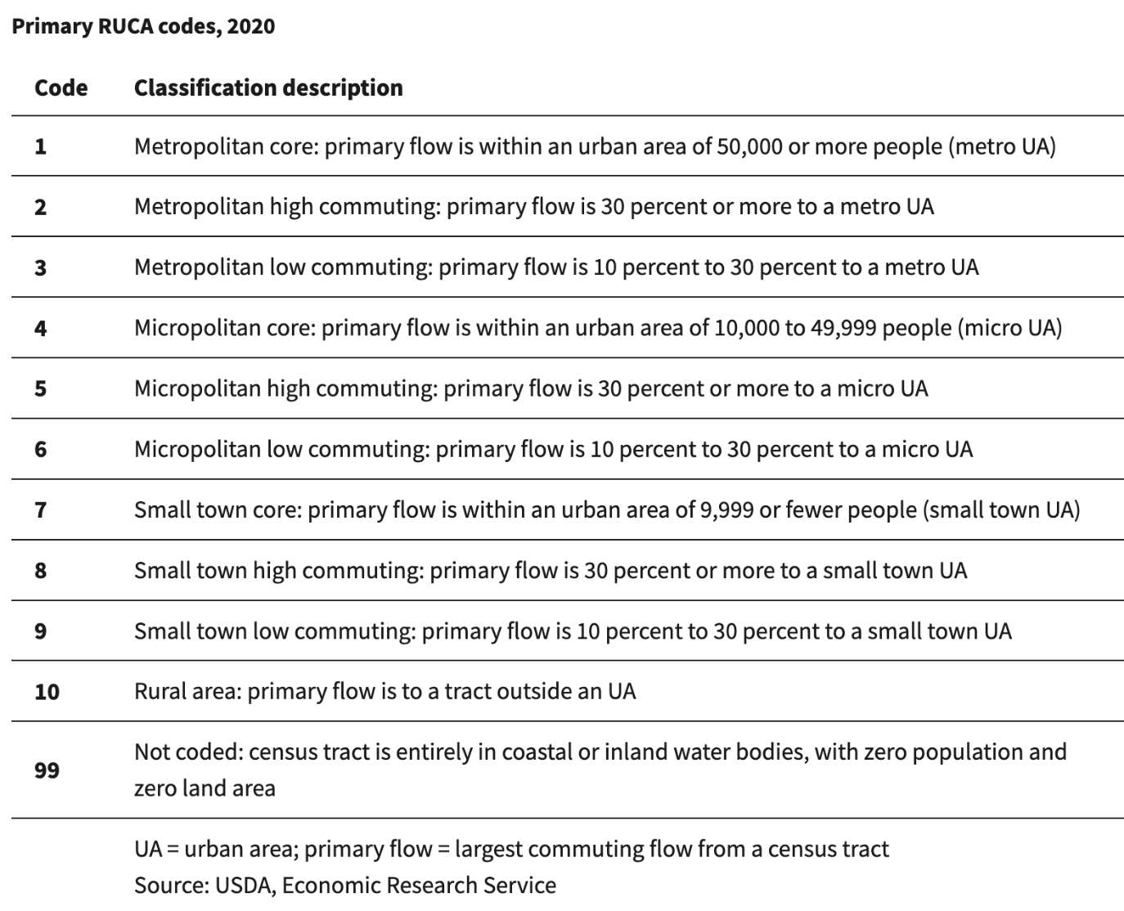

Data Dictionary for PLACES 2020 data:
https://data.cdc.gov/500-Cities-Places/PLACES-Local-Data-for-Better-Health-Census-Tract-D/4ai3-zynv/about_data

Columns (23)
Column Name | Description |  | API Field Name | Data Type
Year | Year |  | year | Text
StateAbbr | State abbreviation |  | stateabbr | Text
StateDesc | State Name |  | statedesc | Text
CountyName | County name |  | countyname | Text
CountyFIPS | County FIPS code |  | countyfips | Text
LocationName | Tract FIPS code |  | locationname | Text
DataSource | Data source |  | datasource | Text
Category | Topic |  | category | Text
Measure | Measure full name |  | measure | Text
Data_Value_Unit | The data value unit, such as "%" for percentage |  | data_value_unit | Text
Data_Value_Type | The data type, such as age-adjusted prevalence or crude prevalence |  | data_value_type | Text
Data_Value | Data Value, such as 14.7 |  | data_value | Number
Data_Value_Footnote_Symbol | Footnote symbol |  | data_value_footnote_symbol | Text
Data_Value_Footnote | Footnote text |  | data_value_footnote | Text
Low_Confidence_Limit | Low confidence limit |  | low_confidence_limit
High_Confidence_Limit | High confidence limit | high_confidence_limit | Number
TotalPopulation | Total population of Census 2010 | totalpopulation | Number
Geolocation | Latitude, Longitude of city centroid (Format: Point(Longitude Latitude)) | geolocation | Point
LocationID | Census tract FIPS | locationid | Text
CategoryID | Identifier for Topic/Category | categoryid | Text
MeasureId | Measure identifier | measureid | Text
DataValueTypeID | Identifier for the data value type | datavaluetypeid | Text
Short_Question_Text | Measure short name | short_question_text

